Physics rests on experiment, and experiment requires measurement. But measurements
are, at best, only approximate. more or less so depending on the instrument doing the
measurement. Although you might be happy to know the distance of the route you took
between New York and Los Angeles to within the tenth of a mile possible on your car's
odometer. you would use a tape measure rather than the car's odometer to measure the
length of your driveway. An uncertainty is an indication of the accuracy of a measure-
ment. The uncertainty depends on the accuracy and calibration of the instrument that is
making the measurement and on how well the instrument can be read. We can best il-
lustrate the meaning of uncertainty with an example. If the width of a page of paper is
measured with a )Uler to be 21.6 cm with an uncertainty of 1 mm (or 0.1 cm), which is
about the best you could manage with a typical ruler. it would be con-ect to say that the
width is 21.6 cm ::1:: 0.1 cm, or 21.6 ::1:: 0.1 cm. (The ::1:: is read as "plus or minus.")
Here, 21.6 cm is called the central value and 0.1 cm the uncertainty around that central
value. In this case, the basis of the uncertainty lie s in how well our eyes can read the
ruler and on the precision with which the ruler was made. We of ten use the term
percentage uncertainty as a measure of the ratio of the uncertainty of a quantity to its
central value. The percentage uncertainty is found by multiplying this ratio by 100. The
percentage uncertainty of our paper measurement is thus ( 0.1 .cm ) (100% ) = 0.5%.
21.6.em:
We also say that a quantity is known to one part in some total. For example, in say-
ing that the paper width was 21.6 cm ::l: 0.1 cm, we could equally well say that the
width is known to 1 part in 216.
We can find the area of the paper by measuring the length and multiplying by
the width. Suppose that we measure the paper's length to be 27.9 ::l: 0.1 cm. The per-
centage uncertainty for the length is 0.4 percent. We find the area by multiplying
21.6 cm by 27.9 cm, which equals 603 cm 2 . Because the mcasurcments of width and
length both contain uncertainties, there will also be an uncertainty in the paper's
area. But what is this uncertainty? A correct way to proceed is to use a process called
quadrature: If PI and P2 are the percentage un certaintie s of two quantities being
multiplied (or divided), the net uncertainty is YI P I + P. If PI and P 2 are about the
same size, we can more simply get an approximate idea of the percentage uncertain-
ty of the product by adding the percentage uncertainties. In the case of the paper's
area, the percentage uncettainty is approximately 0.5% + 0.4% = 0.9%. This
means an unceltainty of (0.009)(603 cm 2 ) = 5 cm 2 , and so the area of the paper is
603 ::l: 5 cm 2 . If PI and P 2 are rather different from one another, then the quadrature
process shows that it is the lm'ger of the two that dominates in the product (or divi-
sion) of the two. Thus, for example, if you used a ruler with a percentage uncertain-
ty of 1 percent for measuring the length of your piece of paper but a ruler with a
percentage uncertainty of 0.1 percent for the width measurement, the area percent-
age uncertainty will be approximately 1 percent.

Significant Figures
Physical quantities are never known with certainty unless they are merely definitions.
The degree of uncertainty in a quantity is implied in the number of digits assigned to its
numerical value. Thus, when we say that an object is 2.00 m long, we mean that it is be-
tween 1.995 and 2.005 m long. If we want to say that the length is somewhere between
1.9995 and 2.0005 m, we say that the length is 2.000 m. In the first case, three signifi-
cant figures are used to describe the object's length; in the second case, the number
of significant figure s is 4. When we say that a sheet of paper has an area of 603 cm 2 , we
are using three significant figures, meaning that there is a good probability that the area
lies between 602.5 and 603.5 cm 2 .
Zeros that are used only to set a decimal point are not part of our count of significant
figures. Thus 0.00035 has 2 significant figures, not 6. To take a more extreme example, we
mentioned in Section 1-1 that the mass of Earth is 5,980,000,000,000,000,000,000,000
kg. Surely we do not know Earth's mass to 25 significant figures! Scientific notation pro-
vides a way to avoid this ambiguity. When we write the mass of Earth as 5.98 x 10 24 kg,
we indicate unambiguously that we know the mass to 3 significant figures; if we knew the
mass to only 2 significant figures, we would write 6.0 X 10 24 kg.
In many cases a quantity is made up of the product of several other quantities each
known to a differing number of significant figures. Our discussion of percentage uncer-
tainties above for PI and P2 when they are velY different from one another (one signifi-
cant figure difference is a factor of 10 in the uncertainty) shows that the number of
significant figures in the product is generally that of the least weJl-known factor. When
sums are invalved, we can use the same rule, but when there are differences and signif-
icant cancellations occur, one has to be more careful (see Example 1--4).
Keep in mind that definitions assign exact values. Thus the inch is defined as
2.54 cm, meaning that 1 in = 2.54000... cm, or exactly 2.54 cm. In effect. there are an
infinite number of significant figures in the number of centimeters in an inch.

It is tempting when using a hand calculator to keep many digits even when the
problem cal1s for fewer. In fact, it is a good strategy to keep many digits through a cal-
culation, because it is sometimes necessary to do this to get the right answer to a suffi-
cient number of significant figures, particularly when subtractions are involved (see
Example 1--4). At the end of a calculation, however, the result should be whittled dawn
to only as many figures as are significant, and this number is generally dictated by the
input parameter with the fewest significant figures.

SIGNIFICANT FIGURES
When physical quantities are measured, the measured values are known only to
within the limits of the experimental uncertainty. The value of this uncertainty can
depend on various factors, such as the quality of the apparatus, the skill of the experimenter,
and the number of measurements performed.
Suppose that we are asked to measure the area of a computer disk label using
a meter stick as a measuring instrument. Let us assume that the accuracy to which
we can measure with this stick is ±0.1 cm. If the length of the label is measured to
be 5.5 cm, we can claim only that its length lies somewhere between 5.4 cm and
5.6 cm. In this case, we say that the measured value has two significant figures.
Likewise, if the label’s width is measured to be 6.4 cm, the actual value lies between
6.3 cm and 6.5 cm. Note that the significant figures include the first estimated
digit. Thus we could write the measured values as (5.5 ±0.1) cm and
(6.4 ± 0.1) cm.
Now suppose we want to find the area of the label by multiplying the two measured
values. If we were to claim the area is (5.5 cm)(6.4 cm) _ 35.2 cm2, our answer
would be unjustifiable because it contains three significant figures, which is
greater than the number of significant figures in either of the measured lengths. A
good rule of thumb to use in determining the number of significant figures that
can be claimed is as follows:

When multiplying several quantities, the number of significant figures in the
final answer is the same as the number of significant figures in the least accurate
of the quantities being multiplied, where “least accurate” means “having the
lowest number of significant figures.” The same rule applies to division.

Applying this rule to the multiplication example above, we see that the answer
for the area can have only two significant figures because our measured lengths
have only two significant figures. Thus, all we can claim is that the area is 35 cm2,
realizing that the value can range between (5.4 cm)(6.3 cm) _ 34 cm2 and
(5.6 cm)(6.5 cm) _ 36 cm2.
Zeros may or may not be significant figures. Those used to position the decimal
point in such numbers as 0.03 and 0.007 5 are not significant. Thus, there are
one and two significant figures, respectively, in these two values. When the zeros
come after other digits, however, there is the possibility of misinterpretation. For
example, suppose the mass of an object is given as 1 500 g. This value is ambiguous
because we do not know whether the last two zeros are being used to locate
the decimal point or whether they represent significant figures in the measurement.
To remove this ambiguity, it is common to use scientific notation to indicate
the number of significant figures. In this case, we would express the mass as 1.5 _
103 g if there are two significant figures in the measured value, 1.50 _ 103 g if
there are three significant figures, and 1.500 _ 103 g if there are four. The same
rule holds when the number is less than 1, so that 2.3 _ 10_4 has two significant
figures (and so could be written 0.000 23) and 2.30 _ 10_4 has three significant
figures (also written 0.000 230). In general, a significant figure is a reliably
known digit (other than a zero used to locate the decimal point).
For addition and subtraction, you must consider the number of decimal places
when you are determining how many significant figures to report.

When numbers are added or subtracted, the number of decimal places in the
result should equal the smallest number of decimal places of any term in the
sum.

For example, if we wish to compute 123 _ 5.35, the answer given to the correct number
of significant figures is 128 and not 128.35. If we compute the sum 1.000 1 _
0.000 3 _ 1.000 4, the result has five significant figures, even though one of the terms
in the sum, 0.000 3, has only one significant figure. Likewise, if we perform the subtraction
1.002 _ 0.998 _ 0.004, the result has only one significant figure even though
one term has four significant figures and the other has three. In this book, most of
the numerical examples and end-of-chapter problems will yield answers having
three significant figures. When carrying out estimates we shall typically work
with a single significant figure.

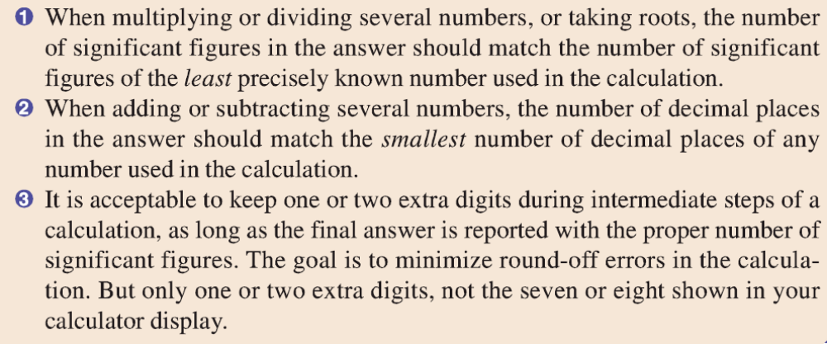

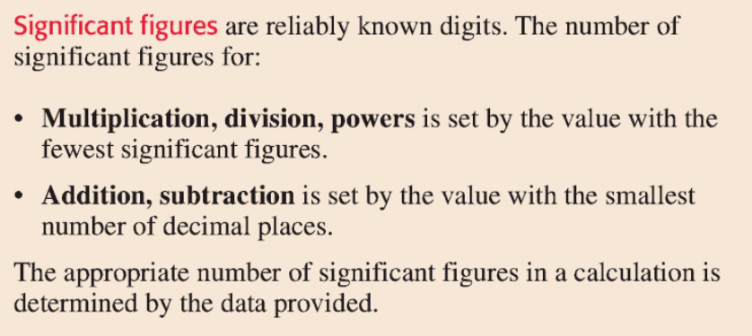
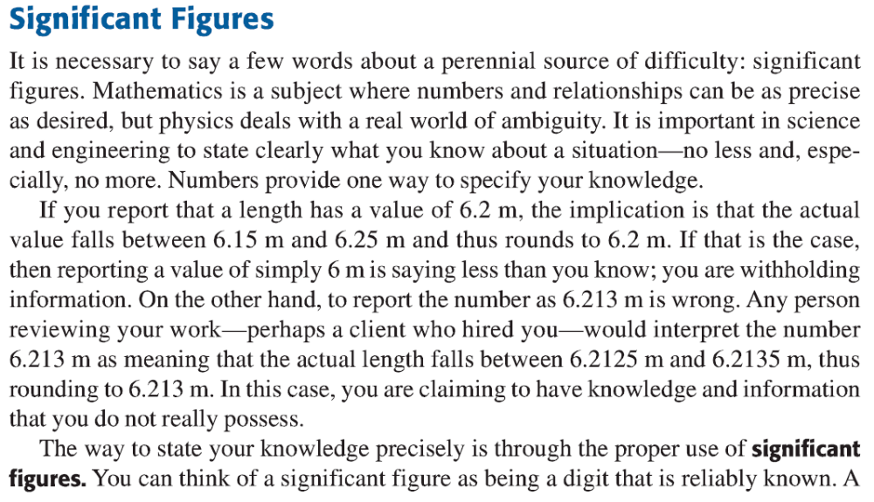
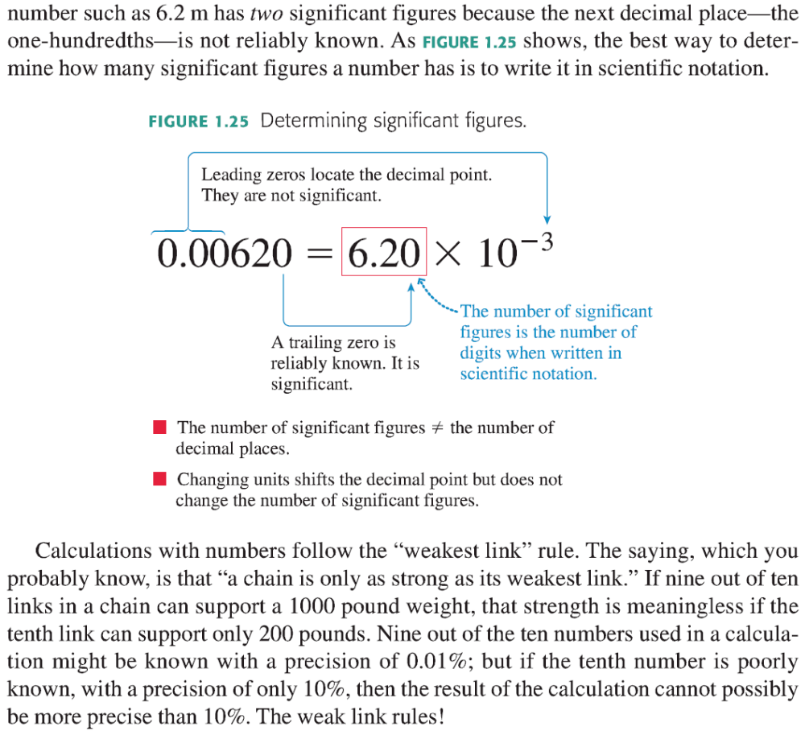
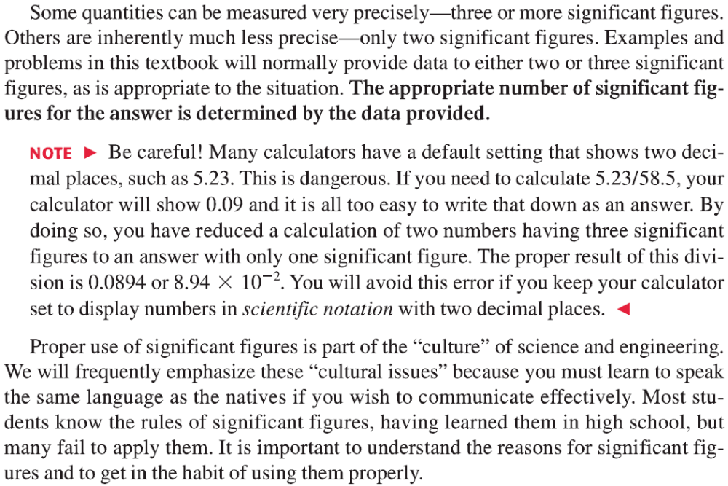

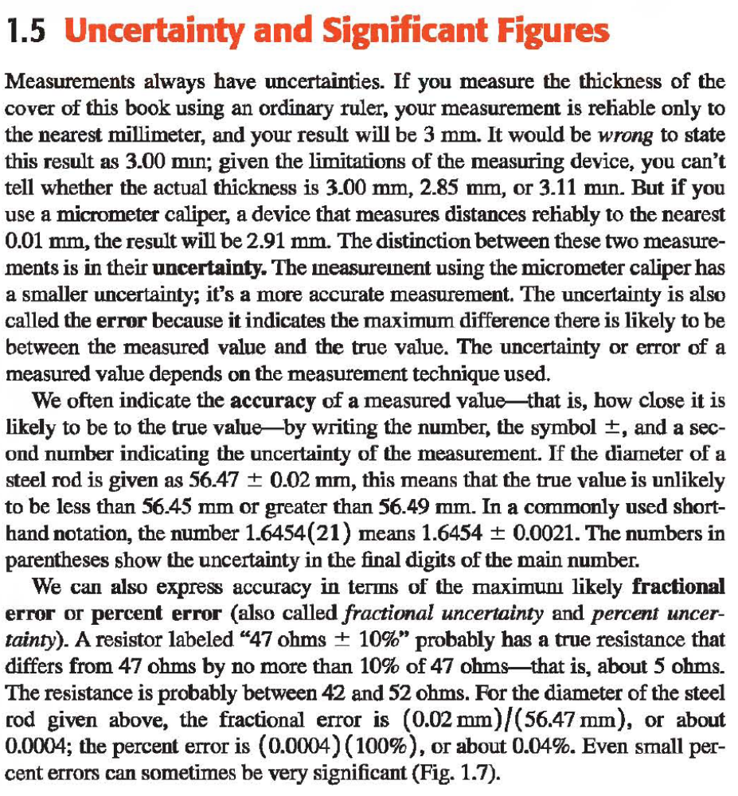
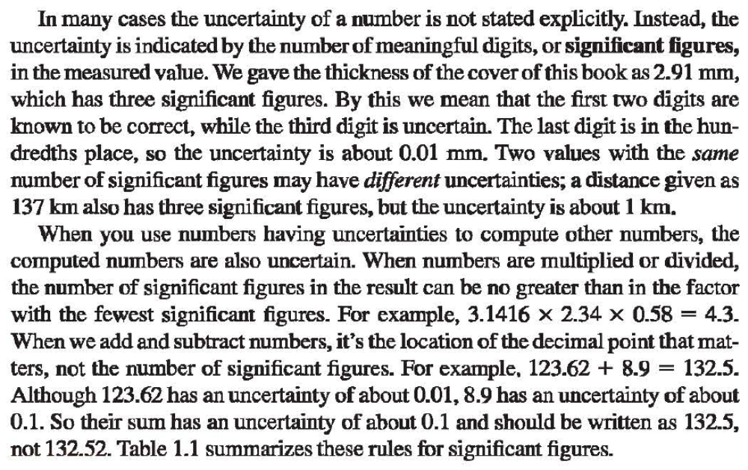
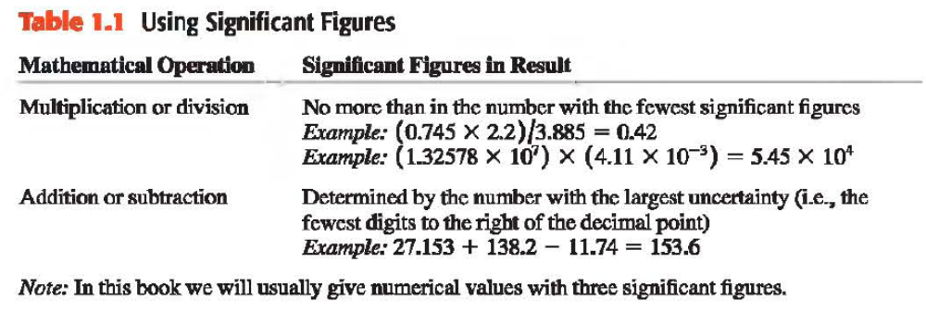
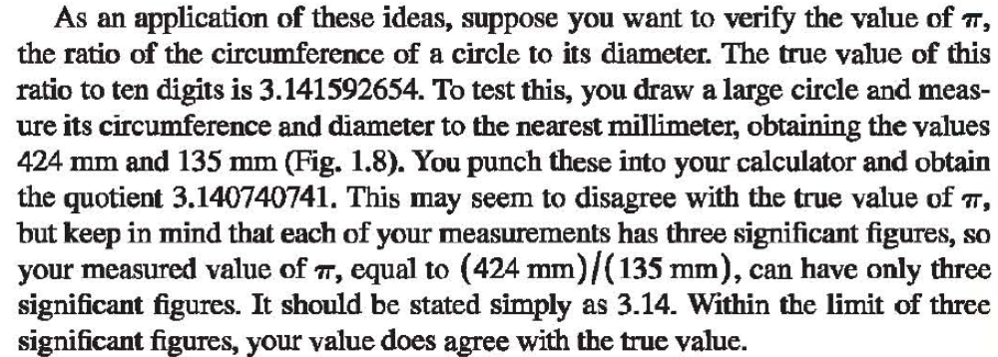
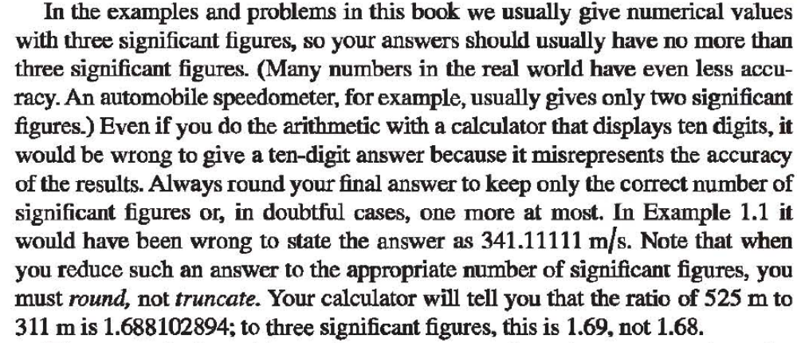
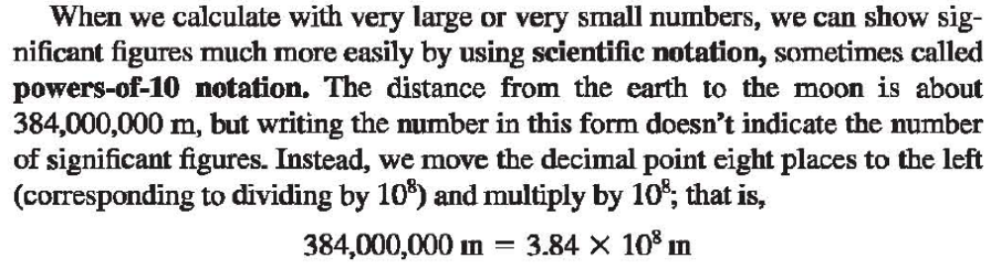
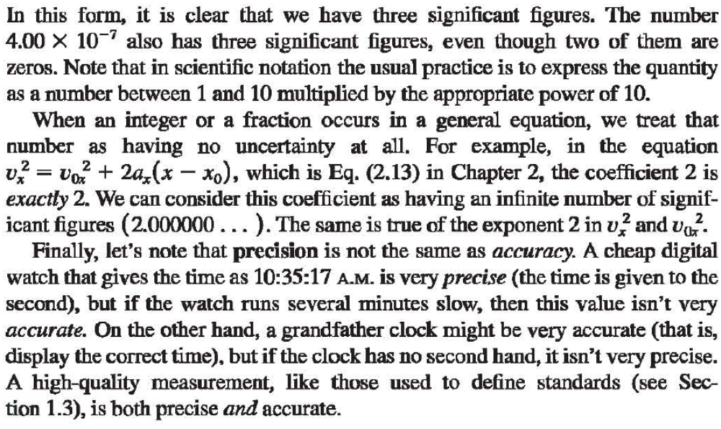
What Is a Measurement?
In a measurement a specific numerical value is assigned to the value of a physical
variable of the sample under investigation. This is done by determining
the ratio of the size of this variable to that of a standard. In order to do so,
the quality of this variable and the units in which it shall be measured must
be defined uniquely.

The Best Estimate
Only when a measurement is brought into scientific context, i.e., when it is
brought into connection with a scientific model or theory, do the measurement
results become scientifically relevant. To become the best estimate of the true
value defined in theory, the measured value has to be corrected and adjusted
when necessary. There are cases in which there is no numerical difference
between the measured value and the best estimate. In such cases one usually
talks about measured values and means best estimates.

Dealing With Data (Numerals)
Numbers can only be displayed with a finite number of digits. This is independent
of the way in which the numbers are handled – by hand or with a
computer. In computers the number of digits are determined by the hard- and
software used; humans are more flexible. In both cases the number of digits to
be used must be sufficient to produce the correct result. On the other hand,
it would be a waste of resources to keep too many digits.
Later on, in Sects. 3.2.4 and 9.2, we will deal with the significance of digits.
Here we shall look only at the different ways of presenting numerical data.

Valid Digits
A number that is the result of a count has no uncertainty, and therefore all
digits are valid. Dealing with decimal numbers is a little more complicated.
The number 10.00, for instance, has four valid digits, 10.0 has only three,
and 0.0010 has only two valid digits. Another way of writing this last number
using only the valid digits is 1.0 × 10−3.
Valid digits may not be left out, even if the valid digit is zero, as in the case
of 10.00.
A valid digit is not necessarily a significant digit. The significance of numbers
is a result of its scientific context (Sect. 3.2.4).

All scientifically relevant quantities must be assigned an uncertainty, as discussed
earlier. This applies to all data values, not only measurement values.
This uncertainty is a statistical measure of data quality. It shows how well
the data, i.e., the best estimate, fits the (unknown) true value. However, it
does not specify the actual deviation between these two values. No data value
is of any use whatsoever in a scientific context without a statement on its
uncertainty.
Consequently, the uncertainty is a fundamental characteristic of any scientific
data value.
Thus uncertainties are probabilistic quantities (Sect. 5.4). In Sect. 5.2 theoretical
aspects of uncertainties are covered. The presence of an uncertainty
is indicated by the symbol ± that we used in Chap. 1 already. An interval
that is symmetric on both sides of a data value and has a total length of
twice the uncertainty is called the 1σ confidence interval (one-sigma confidence
interval, with sigma the symbol for the standard deviation, Sect. 5.1.1).
The true value is expected to lie in this interval with a probability of about
68.27%. Unless otherwise indicated, uncertainties, at least in physical science,
are always these probable uncertainties. In addition, confidence intervals that
are wider by a factor 2 or 3 are common. These are called the 2σ confidence
interval with 95.45% confidence that the true value lies inside it, or the 3σ
confidence interval with 99.73% confidence.
The value of an uncertainty can be induced (external uncertainties,
Sect. 4.2.1) or deduced from the characteristics of the data value (internal
uncertainties, Chap. 6). In the case of measurement values these characteristics
also include properties of the measurement process. Obviously, they are
independent of the model used to present the data values (i.e., of the mathematical
function describing the result). This is why an internal uncertainty
even exists for a single data value (which obviously fits into any model). External
uncertainties, on the other hand, exist only for data sets for which a model
is available (e.g., time invariance, meaning that a measured quantity does not
change in time). Internal uncertainties of experimental data values depend on
the experimental setup; in which way can be best shown by examples.

Terminology
In this book we will refrain from using the term “error” as far as possible;
we will use the term “uncertainty” instead, which seems to be today’s tendency
anyway. Probably, due to historical reasons the term error has often
been preferred when speaking of uncertainties, but calling something an error
evokes the association of it being “wrong”. This is why, even in some books,
wrong measurements and measurements with systematic uncertainties are often
not differentiated. However, uncertainties are an inevitable phenomenon
in the wake of science that has nothing whatsoever to do with mistakes or
wrong measurements.

Explicit Quotation
If a mass is given as m = (30.000 ± 0.004) g, e.g., as a result of weighing,
and if we have no additional (or contradictory) information, we can assume
that the uncertainty stated is the probable uncertainty corresponding to the
1σ uncertainty (as introduced at the beginning of this chapter). In this case
this means that the “true” mass has to lie between 29.996 g and 30.004 g with
a probability of 68%.
Significant Figures (Implicit Quotation)
When we come across scientifically relevant data (best estimates) without
explicit uncertainties, we can get a rough idea of the uncertainty by examining
the digits given, supposing that for the numbers given only significant figures
are stated, and that no significant figures are left out. Therefore we must
always be careful to give all significant figures when presenting scientifically
relevant results!
Let us assume that the raw numbers of the above mass determination
were 29.999735 ± 0.003874 g. From the size of the uncertainty it can be concluded
that the last digit of the data value is definitely not significant. So we
get the following numbers after consecutive rounding to the next even digit
(Sect. 2.3.3):
• 29.99974± 0.00387,
• 29.9997± 0.0038,
• 30.000 ± 0.004, and
• 30.00 ± 0.00.

From these different ways of quoting the result, just one way, namely 30.000±
0.004, gives the data value with the correct number of significant figures.
However, in this case the rounding uncertainty of the uncertainty is ±12.5%
(see rounding uncertainties, below). Thus, unless the total uncertainty of the
uncertainty value is noticeably larger than its rounding uncertainty (at least
by a factor of 3, see Sect. 3.4.1), there are too few significant figures stated
for the uncertainty. To rectify this we must add one (significant) figure to
the uncertainty value, and one insignificant figure to the data value. So, if
the uncertainty in this case is known to better than about 30%, the correct
answer would instead be 29.9997±0.0038. In Sect. 9.2 this subject is discussed
further.
Taking into account the rules of rounding, stating a mass as m = 30.00 g
without giving an uncertainty is equal to the explicit quotation of the uncertainty
yielding m = (30.000 ± 0.005) g. Thus, one has to assume that the
true mass lies between 29.995 g and 30.005 g, with a probability of 68%. Some
might be inclined to drop the trailing zeros and to state that m = 30g. However,
integers are exact, so that no uncertainty can be assigned to such a data
value. To correctly give the result with two digits one must state m = 30. g.
Special care has to be taken when doing calculations using numbers with
implicit uncertainties: The result of the square of 3.5 should be given as 12,
(or 12.2), but under no circumstances should we write 12.25! This is because
3.45×3.45 = 11.9025 and 3.55×3.55 = 12.6025. Here only the first digit after
the decimal point should be given, if it is desirable. Thus we must keep an eye
on the number of significant digits when doing any mathematical operation.
For instance, the square root
√
61.34 = 7.832, as the following two values
(7.8323. . . and 7.8317. . .) can be rounded to 7.832.
The final result of a product can never have more significant digits than the
factor with the smallest number of significant digits.
A self-confident scientist always pays attention to the significance of digits:
When stating best estimates, whether in the experiment logbook or in publications,
we should always quote numbers by giving all significant digits.Whole
numbers should not be used in connection with best estimates. Instead of 8
we should write 8. or 8.0 or 8.00, whichever corresponds to the uncertainty of
the value.
Observe that – for numbers in scientific context – zeros should never be left
out, even if they are the last digit after the decimal point.
When in doubt about the “exact” number of significant figures, one should
adhere to the following rule: one figure too many is much better than one
figure too few. Dropping an insignificant figure is easy; recovering a missing
significant figure without additional information is impossible.
On the Use of Integers
As pointed out, best estimates should always be given with the correct number
of significant digits. How about integers in science? There are, e.g., counting
results that obviously are exact integer values, but only as long as they are
isolated results. As soon as they are included into a scientifically relevant
framework, i.e., as soon as this result is used to establish a best estimate an
uncertainty will result. Already measurement parameters like the clock time
of the measurement introduce uncertainty.
Integer data values taken from established theories are a second kind of
integers in science. So, the rest mass of a photon is zero per definition, but not
because it is a best estimate of a measurement. Likewise, reflection indices of,
e.g., (1,1,1) obtained in a diffraction experiment of X-rays in a single crystal,
are not “best values”, but theoretical values that fit the experimental evidence
best. The same will be true for experimentally determined spin values, nucleon
numbers, etc. In all these cases the use of integers is correct. These integers
taken from theory are the result of an identification process based on the
experimental evidence.
Uncertainties When Rounding
Let us assume that we have a result of x = 4. that was rounded. What is the
uncertainty that was introduced by rounding, i.e., what do we know about the
“parent” number from which this value was derived? All we know is that the
original number was not larger than 4.500. . . and not smaller than 3.500. . .. It
could be any value in this range, and obviously we do not know the sign of the
deviation from 4.! Therefore we can claim that this rounding resulted in an
uncertainty of ±0.5. (This uncertainty is random but not equally distributed,
i.e., it is not normally distributed; the possible values obviously lie within a
rectangular distribution.)

Maximum Uncertainties (Tolerances)
In engineering, for instance, probable uncertainties lead nowhere. If the nominal
diameter of an axis and its bearing were subject to a symmetric 68%
confidence interval, this would result in rejecting 50% of the parts produced.
Of these rejected parts one half would have too much play, and the other half
could not be assembled. So it is usual to use a confidence width of 99.7%
(instead of the 68% confidence width usually used in science), i.e., the 3σ
instead of the 1σ confidence interval is chosen. Assuming a normal distribution
(Sect. 5.2.3) means that the same absolute confidence width results in a
distribution three times narrower. Such a confidence width is often called the
maximum “error”. To further improve the quality of products (especially of
instruments for which a specific accuracy is guaranteed), these 0.3% of the
products lying outside of the confidence width are found and discarded. This
corresponds to a truncation of the uncertainty distribution on both ends. In
addition, in engineering cases like above it makes sense not to use symmetric
uncertainties, but instead use one-sided tolerances.
To account for worst-case situations (all deviations having the same sign)
uncertainty contributions to maximum uncertainties must be added linearly
rather than in quadrature (Sect. 3.4), as is done with probable uncertainties.
As an arithmetic sum can never be smaller than a geometric one, regular
addition guarantees that the correct total uncertainty is under no circumstances
larger than the uncertainty calculated this way.
Therefore, manufacturers of measuring devices who have to guarantee the
performance of their instrument usually suggest to add the given uncertainty
components linearly.
A detailed judgment of tolerances is generally not possibly without indepth
information, which can sometimes be hard to come by, as can be seen
in the following example dealing with electrical resistors.

Limits
If zero lies inside one of the uncertainty bars of a best estimate, but zero (and
values beyond zero) are not possible due to theory, it does not make sense to
choose a symmetrical uncertainty interval around the best estimate. In this
case the upper (or the lower) end of the uncertainty interval will be chosen
as the upper (or lower) limit for the desired quantity. The best estimate will
then be given as smaller (or larger) than this limit with a confidence given by
that of the confidence interval used.

Determining combined standard uncertainty
5.1 Uncorrelated input quantities
This subclause treats the case where all input quantities are independent (C.3.7). The case where two or more input quantities are related, that is, are interdependent or correlated (C.2.8), is discussed in 5.2.
5.1.1 The standard uncertainty of y, where y is the estimate of the measurand Y and thus the result of the measurement, is obtained by appropriately combining the standard uncertainties of the input estimates x1, x2, ..., xN (see 4.1). This combined standard uncertainty of the estimate y is denoted by uc(y).
2.2 The term “uncertainty”
The concept of uncertainty is discussed further in Clause 3 and Annex D.
2.2.1 The word “uncertainty” means doubt, and thus in its broadest sense “uncertainty of measurement”
means doubt about the validity of the result of a measurement. Because of the lack of different words for this general concept of uncertainty and the specific quantities that provide quantitative measures of the concept, for example, the standard deviation, it is necessary to use the word “uncertainty” in these two different senses.
2.2.2 In this Guide, the word “uncertainty” without adjectives refers both to the general concept of uncertainty and to any or all quantitative measures of that concept. When a specific measure is intended, appropriate adjectives are used.
2.2.3 The formal definition of the term “uncertainty of measurement” developed for use in this Guide and in the VIM [6] (VIM:1993, definition 3.9) is as follows:
uncertainty (of measurement)
parameter, associated with the result of a measurement, that characterizes the dispersion of the values that could reasonably be attributed to the measurand
2.3.1 standard uncertainty
uncertainty of the result of a measurement expressed as a standard deviation
2.3.2 Type A evaluation (of uncertainty)
method of evaluation of uncertainty by the statistical analysis of series of observations
2.3.3 Type B evaluation (of uncertainty)
method of evaluation of uncertainty by means other than the statistical analysis of series of observations
2.3.4 combined standard uncertainty
standard uncertainty of the result of a measurement when that result is obtained from the values of a number of other quantities, equal to the positive square root of a sum of terms, the terms being the variances or covariances of these other quantities weighted according to how the measurement result varies with changes in these quantities
2.3.5 expanded uncertainty
quantity defining an interval about the result of a measurement that may be expected to encompass a large fraction of the distribution of values that could reasonably be attributed to the measurand
6.2 Expanded uncertainty
6.2.1 The additional measure of uncertainty that meets the requirement of providing an interval of the kind indicated in 6.1.2 is termed expanded uncertainty and is denoted by U. The expanded uncertainty U is obtained by multiplying the combined standard uncertainty uc(y) by a coverage factor k:
U = kuc ( y) (18)
The result of a measurement is then conveniently expressed as Y = y ± U, which is interpreted to mean that the best estimate of the value attributable to the measurand Y is y, and that y − U to y + U is an interval that may be expected to encompass a large fraction of the distribution of values that could reasonably be attributed to Y. Such an interval is also expressed as y − U u Y u y + U.
6.2.2 The terms confidence interval (C.2.27, C.2.28) and confidence level (C.2.29) have specific definitions in statistics and are only applicable to the interval defined by U when certain conditions are met, including that all components of uncertainty that contribute to uc(y) be obtained from Type A evaluations. Thus, in this Guide, the word “confidence” is not used to modify the word “interval” when referring to the interval defined by U; and the term “confidence level” is not used in connection with that interval but rather the term “level of confidence”. More specifically, U is interpreted as defining an interval about the measurement result that encompasses a large fraction p of the probability distribution characterized by that result and its combined standard uncertainty, and p is the coverage probability or level of confidence of the interval.

Reporting uncertainty
When the measure of uncertainty is uc(y), it is preferable to state the numerical result of the measurement in one of the following four ways in order to prevent misunderstanding. (The quantity whose value is being reported is assumed to be a nominally 100 g standard of mass mS; the words in parentheses may be omitted for brevity if uc is defined elsewhere in the document reporting the result.)
1) “mS = 100,021 47 g with (a combined standard uncertainty) uc = 0,35 mg.”
2) “mS = 100,021 47(35) g, where the number in parentheses is the numerical value of (the combinedstandard uncertainty) uc referred to the corresponding last digits of the quoted result.”
3) “mS = 100,021 47(0,000 35) g, where the number in parentheses is the numerical value of (the combined
standard uncertainty) uc expressed in the unit of the quoted result.”
4) “mS = (100,021 47 ± 0,000 35) g, where the number following the symbol ± is the numerical value of (the combined standard uncertainty) uc and not a confidence interval.”
NOTE The ± format should be avoided whenever possible because it has traditionally been used to indicate an interval corresponding to a high level of confidence and thus may be confused with expanded uncertainty (see 7.2.4). Further, although the purpose of the caveat in 4) is to prevent such confusion, writing Y = y ± uc(y) might still be misunderstood to imply, especially if the caveat is accidentally omitted, that an expanded uncertainty with k = 1 is intended and that the interval y − uc(y) u Y u y + uc(y) has a specified level of confidence p, namely, that associated with the normal distribution (see G.1.3). As indicated in 6.3.2 and Annex G, interpreting uc(y) in this way is usually difficult to justify.

7.2.4 When the measure of uncertainty is U, it is preferable, for maximum clarity, to state the numerical result of the measurement as in the following example. (The words in parentheses may be omitted for brevity if U, uc, and k are defined elsewhere in the document reporting the result.)
“mS = (100,021 47 ± 0,000 79) g, where the number following the symbol ± is the numerical value of (an expanded uncertainty) U = kuc, with U determined from (a combined standard uncertainty) uc = 0,35 mg and (a coverage factor) k = 2,26 based on the t-distribution for v = 9 degrees of freedom, and defines an interval estimated to have a level of confidence of 95 percent.”

This document presents UCAnalysis framework for Mathematica that can be used for computer-aided uncertainty analysis while solving textbooks problems in physics.

Background

Unless defined, all physical quantities are measured values and never known with certainty; these input uncertainties carry over calculations and give a combined uncertainty to the calculated result. When using electronic calculators, it is easy to neglect or overestimate precision of this propagated uncertainty.
Back in the old days of slide rule calculations, it was a rare case that a calculated result was reported with an overestimated precision; an error analysis was an intrinsic part of calculation algorithms. This trouble emerged in the age of electronic calculators, causing that most of the physics textbooks nowadays are emphasizing simple rules of uncertainty propagation with significant figures.
However, while these rules are an efficient means of propagating uncertainty in many simple calculations, they are not valid for non-linear mathematical functions or whenever there are many steps throughout the calculation. Computer-aided mathematics can help to overcome these difficulties, enabling a student with the ability to play easily with different estimates and uncertainties of input quantities, so to take a deeper understanding of the uncertainty of the calculated result.

Propagation of Uncertainty
Rules of Significant Figures
It is usual that, in problems in physics textbooks, uncertainties of input quantities are implicitly quoted with significant figures rather than explicitly with the best estimate, uncertainty and specified level of confidence; however, identifying the correct number of significant figures in input quantities sometimes can be problematic, for, first, there is an inherent ambiguity to determine the number of significant figures in quantities ending with one or more zeros but without decimal point (like 100 °C), and second, one should not miss to recognize all defined input quantities (having the infinite number of significant figures; like quantities in 25.4 mm/inch or T/K = t/°C + 273.15.
When relying on significant figures, estimation of the uncertainty of a calculated result may be done by using some simple rules for addition and multiplication during calculations. These rules can be stated as follows:
For multiplication and division: the number of significant figures that are reliably known in a product or quotient is the same as the smallest number of significant figures in any of the original numbers.
For addition and subtraction: the result should be rounded off to the last decimal place reported for the least precise number.
While these rules are an efficient means of propagating uncertainty in many simple calculations, they are not valid whenever non-linear mathematical functions are involved (like exponentials, logarithms and trigonometric functions) or when there are many steps throughout the calculation, which is often the case. Further sections demonstrate other, more reliable methods for uncertainty analysis.
Combined Standard Uncertainty
Let Y=f(X₁,X₂,... X_{n}) be a functional relationship between input quantities X_{i} (conventionally expressed as X_{i}=x_{i}±u_{i}) and the result Y.
If input quantities X_{i} are independent (uncorrelated) and their uncertainties are standard deviations of measured data (called “standard uncertainties” u_{i} of the input estimates x_{i}), we can determine a combined standard uncertainty u_{c} of the output estimate y=f(x₁,x₂,... x_{n}) using the law of propagation of uncertainties (commonly called the “root-sum-of-squares” or RSS method):
u_{c}=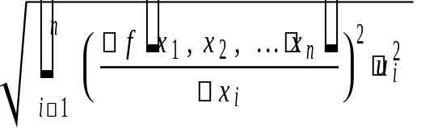 where Y=y±u_{c}, so
Y=f(x₁,x₂,... x_{n}) ±
When this is done, the combined standard uncertainty u_{c} should be equivalent to the standard deviation of the result, making this uncertainty value correspond with a 68.27 % (1) confidence interval. If a wider confidence interval is desired, the uncertainty can be multiplied by a coverage factor (usually k = 2 or 3) to provide an uncertainty interval U=k u_{c} (called expanded uncertainty) that is believed to include the true value with a confidence of 95.45 % or 99.73 % respectively.
Note again that the previous expressions are valid only if input quantities are estimated by standard uncertainties, i.e. before combination, all uncertainty contributions must be expressed as standard deviations. This may involve conversion from some other measure of dispersion. The following rules give some guidance for converting an uncertainty component to a standard deviation.
If the uncertainty component was evaluated experimentally from the dispersion of repeated measurements, it can readily be expressed as a standard deviation.
If an uncertainty estimate is derived statistically from previous results and data, it may already be expressed as a standard deviation. However, where a confidence interval is given with a level of confidence, in the form ±U at p%, then we should divide the value expanded uncertainty U by the appropriate percentage point of the normal distribution for the level of confidence given to calculate the standard deviation.
If limits ± are given without a confidence level and there is reason to expect that extreme values are likely, e.g. when reading from digital instruments or when using significant figures, it is normally appropriate to assume an uniform distribution, with a standard deviation of /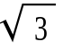.
If limits ± are given without a confidence level, but there is reason to expect that extreme values are unlikely, e.g. when reading from analog instruments, it is normally appropriate to assume a triangular distribution, with a standard deviation of /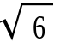.
Bounds of Uncertainty and Absolute Maximum Uncertainty
When the origin or correlation of input quantities are not known, to account for worst-case situations, the only we can state is that uncertainty interval of the calculated result is between local minimum f_{min} and local maximum f_{max} of the function f(X₁,X₂,... X_{n}) on the domain {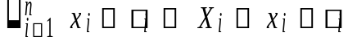} of input quantities. In this case, the output interval [f_{min}; f_{max}] is almost never symmetrical around the central value y=f(x₁,x₂,... x_{n}).
Alternative way similar to RSS is to, based on first-order Taylor series approximation of f, calculate an absolute maximum uncertainty max by adding up all maximum absolute uncertainty contributions linearly, rather than as squared like in RSS:
max=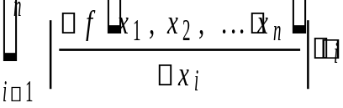
where i is the absolute maximum uncerainty of the input quantity X_{i}. Since an arithmetic sum can never be smaller than a geometric one, linear addition guarantees that the correct total uncertainty, calculated using RSS-like method, is under no circumstances larger than the uncertainty max, i.e. inequality u_{c}max always holds.
Monte Carlo Method
As it is often difficult to calculate the combined standard uncertainty in complex systems, Monte Carlo simulation can be used as an experimental probabilistic method since computers can easily simulate a large number of experimental trials that have random outcomes. When applied to uncertainty estimation, random numbers are used to randomly sample uncertainty intervals of input quantities automatically taking care of correlation between input variables and possible different statistical distributions.
This approach involves the following steps:
Select a distribution i to describe possible values of input quantity X_{i} based on available information (Table 1 in JCGM 101:2008, p. 21), e.g. uniform distribution if lower and upper limits are known, or normal distribution if best estimate and associated standard uncertainty are known.
Generate random data from this distribution x_{i}=rand(i).
Use the generated data as possible values the model to produce output estimates y=f(x₁,x₂,... x_{n}).
Calculate expected value and standard deviation of produced output.

